**LOCATION, LOCATION, LOCATION: DETERMINING WHERE THINGS ARE**

**(Or: Attack of the Giant Space Bananas!)**

**REFERENCES:**

Localization of sources in the sky are derived from SCIVR screenshots as well as:

<http://www.virgo-gw.eu/skymap.html>

Information on detected LIGO events:

<https://losc.ligo.org/events/>

The LIGO and VIRGO gravitational wave detectors take advantage of their great separation to better localize the source of the signals they receive. But it doesn’t work to precisely determine where the source is. To understand why, consider the following scenario:

*You’re sitting at your desk, minding your own business, with your earbuds in. Suddenly, over the sound of the music you hear a mysterious CRACK!*

*How do you know where the sound came from? Was it in the room? In the house? Or was it across town?*

*Within seconds, your friend, who lives across town, texts you. “DID U HEAR THAT??!!”*

*At this point, you are pretty sure that the sound did not come from your room. Unfortunately, that’s about all you know, though.*

*Minutes later you get another text. “THERE IT IS AGAIN!!”*

*You are about to respond “??????” when you hear it.*

Now you know that whatever caused the second sound was…

1. … closer to you than it was to your friend
2. … closer to your friend than it was to you
3. … the same distance from you and your friend
4. You can’t conclude anything about the location of the source

EXPLAIN:

Here’s a diagram showing your house and your friend’s house and four possible locations of the second sound.

YOUR HOUSE



2

1

111



3

FRIEND’S HOUSE

4

QUESTION: Which location (1-4) is the most likely position of the second sound?

EXPLAIN:

Draw on the diagram at least two other locations that could be the position of the second sound.

*You get on the phone to talk to your friend after the second sound, and while you’re trying to figure out what’s going on, you both hear something at the same time.*

QUESTION: Which location (1-4) could be the source of the third sound?

Draw on the diagram at least two other locations that could be the position for the third sound.

What, if anything, would help you better localize the source of the sounds if more occur?

One thing that you’ve been ignoring so far is that there are more than two dimensions in the universe. Sure, the source of the sound could have been at ground level, but it could also have been above the ground or deep beneath it.

In the case of the third sound – the one that you and your friend heard simultaneously – its origin could have been anywhere along a line that cut between your two houses or directly above or directly below that line. The only rule is that the source of the sound was the same distance from both your house and your friend’s house.

If you look at all the possible locations that are equally distant from you and your friend, they actually create a giant plane cutting through the mid-line.

For signals coming from space, that plane shows up as a giant circle projected into the sky. One such circle is something called the “celestial equator,” and it’s just the projection of Earth’s equator into the sky. This helps astronomers indicate the position of things in the sky, just as latitude and longitude indicate positions of things on Earth’s surface.

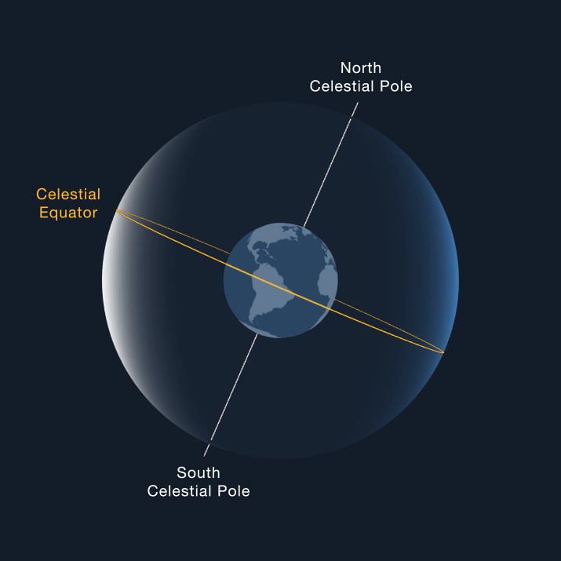

FIGURE 1: The plane that cuts through Earth’s equator appears as a giant circle projected onto the sky. This is called the Celestial Equator. Image from <https://solarsystem.nasa.gov/basics/chapter2-2/>

Just as being the only person hearing a sound is not helpful in figuring out where the sound came from, knowing that a signal came from one of an infinite number of possible points is not particularly helpful. Having multiple observers – and knowing how fast your signal is traveling – helps scientists better localize the source.

LIGO’s detectors are located in two cities in the USA: Hanford, Washington and Livingston, Louisiana. These cities are separated by a straight line distance of 3002 kilometers (their overland distance is slightly greater because Earth is curved).

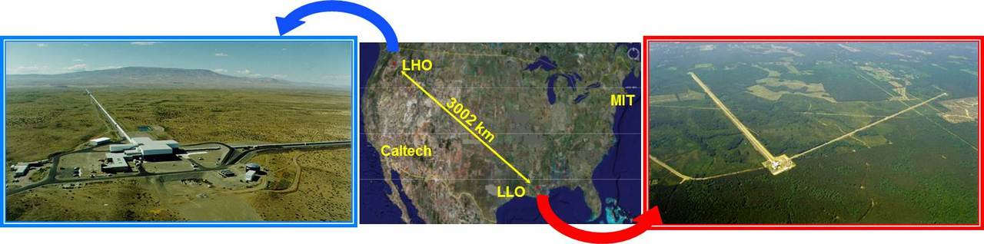

Image credit:

<https://www.ligo.caltech.edu/WA/page/ligo-detectors>

The gravitational wave signals that they detect move at the speed of light, or 300,000 km/s.

QUESTION: How long would it take a gravitational wave to travel in a straight line from Hanford to Livingston?

QUESTION: Imagine that the two detectors record a gravitational wave event SIMULTANEOUSLY. What does this mean about the direction of the source? [think about the example with the mystery sound]

For the first gravitational wave detection in 2015, two gravitational wave observatories were up and running: The LIGO facility in Livingston, Louisiana, USA and the LIGO facility in Hanford, Washington, USA.

The Livingston facility detected the wave seven milliseconds (0.007 s) before the Hanford facility.

Now take a look at the map below.

QUESTION: What does this observation mean about the location of the source?

1. It came from the southern sky and traveled basically northward
2. It came from the northern sky and traveled basically southward
3. It came from directly above or directly below the red line indicated on the map below and traveled directly “down” through the USA
4. It came exactly from the direction indicated by the white arrow

EXPLAIN:

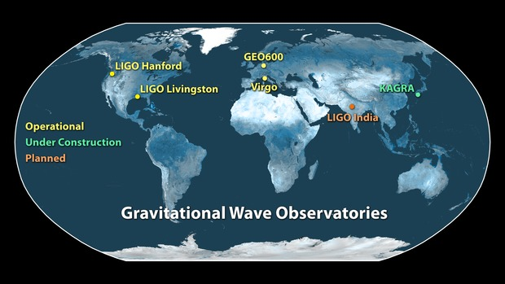

IMAGE SOURCE: <https://www.ligo.caltech.edu/image/ligo20160211c>

Another added feature is that gravitational waves, like EM waves, are “transverse” – the compression/elongation is perpendicular to the direction that the wave is travelling. So if a gravitational wave were coming out of the page towards you (or going directly into the page), it would result in the following behavior (definitely not to scale): One arm elongates while the second arm shrinks. Then both arms return to “normal.” Then the first arm shrinks while the second elongates. Then both return to normal. Then the cycle repeats as long as gravitational waves are coming through the detector.

*A schematic of how LIGO’s perpendicular arms respond to a gravitational wave traveling out of the page or into the page.*

QUESTION: Imagine that the diagram below is LIGO. It has made a detection where only the arm along the y-axis was observed to elongate and shrink. What does this mean?

1. LIGO is broken
2. The GW is coming from the top of the page (from the +y direction)
3. The GW is coming from either the left or right of the page (from the -x or +x direction)
4. The GW is coming out of the page towards you
5. The GW is coming either from the top or bottom of the page (from the +y or –y direction)

EXPLAIN:

SITUATION: Gravitational waves are approaching a GW observatory at a 45-degree angle, as depicted by the green arrow below.

QUESTION: How would the arms of the GW observatory be affected in this case?

1. Neither arm would lengthen or contract at all
2. Only the arm along the x-axis would elongate and shrink
3. Only the arm along the y-axis would elongate and shrink
4. Both arms would elongate and shrink MORE than they would if the same event came out of the page
5. Both arms would elongate and shrink LESS than they would if the same event came out of the page

EXPLAIN:

The various gravitational wave observatories have different arm orientations. These, along with the arrival times at the observatories, help scientists better narrow down the possible direction for the source of the gravitational waves.

**USING YOUR SCIVR APP, USE SKYMAPS TO FIND THE LOCALIZATION AREAS FOR GW 150914, GW170104, AND GW 170817. You may have to pan around a bit.**

**Which event had the smallest localization area?**

**Largest?**

For the first detection – GW 150914 – both LIGO facilities were working, but all that scientists could deduce from the data was that the source was somewhere in the ring of sky indicated by the blue region below. That’s a huge patch of sky. Frantic follow-up searches by telescopes turned up nothing. The collision that resulted in this gravitational wave event gave off no light that we could detect.

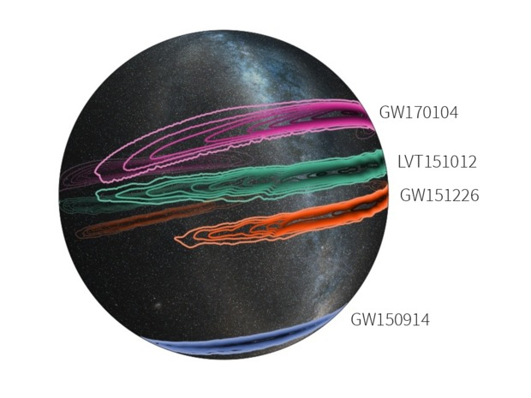

In 2017, scientists got very lucky. THREE gravitational wave observatories were working, allowing them to more precisely pinpoint the source.

LIGO narrowed it down to the green bands shown below, but the third observatory – Virgo, in Italy – narrowed it even further to the dark green patch BY NOT OBSERVING THE EVENT! This was because the gravitational waves were coming in from one of VIRGO’s “blind spots,” regions where the detector is not sensitive. As in the example above, when gravitational waves come from a 45 degree angle in the plane of the detector arms, the arms will not shrink and elongate as much, which makes detections more difficult.

Because the localization region dictated by the three GW observatories was so small, it was possible for observatories to quickly follow up to find any signal in the more familiar electromagnetic waves (i.e., light), and the event showed up across the full electromagnetic spectrum. Future observations will involve even more gravitational wave observatories and be easier to localize.

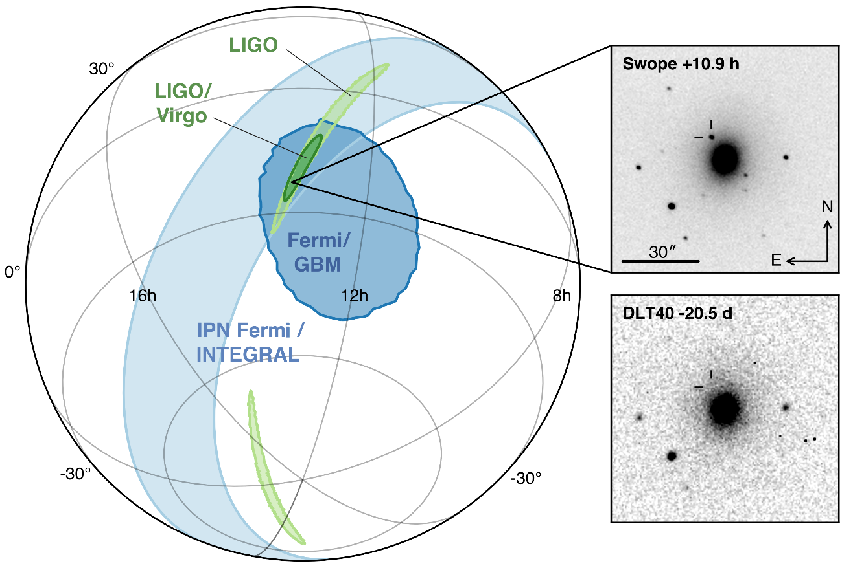

Image from <http://www.virgo-gw.eu/images/GW170817_orig.png>

FURTHER READING:

<https://www.wired.com/2016/02/ligo-aint-gravitational-wave-detector-observatory/>

<https://www.ligo.caltech.edu/image/ligo20170601e>

[http://www.thephysicsmill.com/2016/03/06/direction-ligos-gravitational-waves/](http://www.thephysicsmill.com/2016/03/06/direction-ligos-gravitational-waves/http://www.thephysicsmill.com/2016/03/06/direction-ligos-gravitational-waves/)

<https://www.ligo.org/science/Publication-GW170814/index.php>

<https://www.ligo.org/scientists/GW100916/GW100916-geometry.html>

<http://www.thephysicsmill.com/2016/03/06/direction-ligos-gravitational-waves/>

<https://www.wired.com/2016/02/using-gravitational-waves-to-pinpoint-colliding-black-holes/>