STORIES IN THE WAVES: AN INTRODUCTION TO THE ELECTROMAGNETIC SPECTRUM, WITH A GRAVITATIONAL WAVE BONUS

Using the All-Sky module in the SCIVR app, take a brief tour of the universe. Look at the views of the sky in various wavelengths and compare and contrast the images.

- How are the views similar? How are they different?

- Are there any features that show up in some wavelengths but not in others?

- Can you find the centre of our Galaxy?

- In which wavelength range do you seem to observe the greatest amount of information? In which wavelength range do you seem to observe the smallest amount of information?

- If all we observed were what we can see with our eyes (the visible range), would we have a complete picture? In particular, what can you observe in other images that is missing in the visible light image? Be specific about WHICH image you’re discussing.

Explore:
Your instructor is now going to show you a video. Your job will be to predict what you’ll see.

6. (1:54) Which side of the narrator is hotter? Which side is cooler? How can you tell?

7. (2:12) Why can’t you see the person in infrared light when she is below the surface of the water?

8. (3:10) How do you think a cold-blooded reptile will look in the infrared?

9. (3:14) What about giraffes? Will their dark spots appear darker or brighter in the infrared?

10. (3:17) Regarding #9, why do you think this is the case?

11. (3:19) How do you think the horns of an animal compare to the rest of its body in the infrared?

12. (3:35) Based on what we learned about giraffes, looking at the zebra in the infrared, which color do you think corresponds to the black stripes and which to the white?

13. (3:51) Do you think the horns of the rhinoceros are the same as the horns of the ibex we saw before?

Explain:
Because our eyes are limited by what they can detect, and because different types of light are either transmitted or blocked by different materials, we must observe the sky in multiple wavelengths. By studying celestial objects at different wavelengths, we can get a bigger picture of what is out there and what is going on than if we only observed at visible wavelengths.

One of the greatest problems for observing in visible light is dust. Interstellar dust is roughly the same size as the wavelength of visible light. As a result, dust will block visible light, preventing it from passing through space.

As we look out into space, we can only see so much because dust blocks our view in certain directions. By observing in other wavelengths though, we can see beyond interstellar dust because while it may block visible light, it doesn’t block other wavelengths of light.

Atmospheric Windows

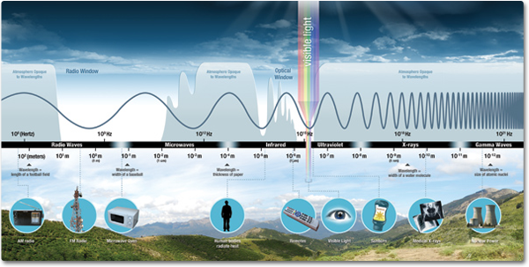
(http://missionscience.nasa.gov/images/ems/emsIntro_mainContent_Electromagnetic_Spectrum.png)

We discovered that for many objects, certain wavelengths of light can pass through while other wavelengths are blocked. Earth’s atmosphere behaves the same way. Due to molecules in the Earth’s atmosphere, some wavelengths of light can easily pass through while others are absorbed or scattered.

14. Looking at the image above, which wavelength ranges easily make it through the Earth’s atmosphere down to the surface?

15. Which wavelength ranges are completely blocked by the Earth’s atmosphere?

16. Which wavelength ranges are partially blocked?

Because many wavelengths of light can’t reach the Earth’s surface, it is important to deploy telescopes into space, above the Earth’s atmosphere, so we can see the Universe in all wavelengths. A list of multiwavelength observatories can be found at http://science.nasa.gov/astrophysics/missions/

BUT WHAT ABOUT GRAVITATIONAL WAVE ASTRONOMY?
Unlike light waves, gravitational waves are ridiculously hard to detect. Light waves result from the interplay between electricity and magnetism, forces that are a hundred trillion trillion trillion times stronger than gravity. Those waves bound around the universe, interacting with all the charged particles they encounter. As a result, it’s practically child’s play to create something that generates radio waves. Just hook up a battery to a wire, and then unhook it, then hook it up again, and repeat. Or find a capacitor and inductor and make them do the oscillating work for you. As it turns out, charged particles, like siblings, really enjoy bothering each other, so this simple radio transmission could easily be picked up by a receiver and translated.

But masses are much more timid, their voices carrying as fast and as far as light waves, but at a much, much, much lower volume. By “volume,” we don’t mean literal loudness. What we measure is the compressing and stretching of the tapestry that makes up spacetime. Still, all the analogies and animations you’ve watched make it appear as though swells comparable to those encountered in a wicked storm at sea were sweep through our neighborhood. Yet it took a century and every scrap of scientific ingenuity we possessed to devise and build a detector to listen in on the unfathomable energy released cosmic collisions. The first gravitational wave event discovered – GW150914 – sent out more power in gravitational waves than the total power of

Every.
Single.
Star.
In.
The.
Observable.
Universe.

We’ve seen individual stars explode ten times farther away than GW150914, and those events released far less energy.

Interestingly, there was not a hint that the GW150914 event emitted ANY electromagnetic radiation.

17. Knowing what you currently know about electromagnetic radiation, what does this tell you about the OBJECTS involved in that event?

In 2017, the gravitational wave event GW170817 was coincident with detections in radio waves, infrared, visible, ultraviolet and x-rays. In fact, two seconds after the culmination of the event, the Fermi Gamma Ray satellite detected a short burst of gamma rays. It was determined that the event occurred in a galaxy 144 million light years away.
What this means is that dinosaurs were roaming our planet when the gravitational waves and the electromagnetic waves were emitted from their source, and after spending 144 million years zipping through space, they finally arrived at our various detectors.

18. Knowing what you currently know about electromagnetic radiation, what can you say about the SPEED of gravitational waves compared to the speed of light?

19. Knowing what you currently know about electromagnetic radiation, what do you expect to be different about the GW170817 source compared to the GW150914 source?

