**ALL SPACED OUT: SCALE MODELS OF THE SOLAR SYSTEM**

**INSTRUCTOR’S EDITION**

**INTRODUCTION**: How do the objects in the solar system and the universe really compare in size? And how far away are things really? In the SCIVR “Bigger than Big” and “Solar System” apps, you get a sense of relative sizes of solar system objects and our stellar neighbors, but it’s impractical in this environment to simulate the actual sizes involved, as some objects would take over the entire field of view! Even simulating motion at light speed, it would take eight minutes to travel from the Sun to Earth. If you compress the Sun-Earth travel time to just one second, it would *still* take nearly a full day to get to the next nearest star. And there wouldn’t be much of interest to look at during those hours!

This activity picks up where SCIVR leaves off: Visualising and modeling the sizes and distances involved in the “nearby” universe: the solar system. In fact, we can use our models of the universe to learn how astronomers originally determined actual distances between solar system objects (e.g., the Earth-Sun distance).

In this activity, students will explore the relative sizes of familiar objects (Sun, Earth, and Moon), and create a scale model of the distances involved in the solar system.

More advanced students will be able to compute the Earth-Sun distance using the transit of Venus method.

**Notes to the instructor and answers to questions are in ALL CAPS.**

**This activity was created in part with the support of the NASA Science Mission Directorate Education and Public Outreach for Earth and Space Science (EPOESS), which is part of the Research Opportunities in Space and Earth Sciences (ROSES), Grant Number NNX12AH11G**

**MATERIALS REQUIRED:**

One 3-lb tub of playdough per group

One large circular cutout to represent the Sun AND many small balls/circles of various sizes

One roll of cash-register receipt tape

Smartphone + SCIVR app + VR viewer.

Protractor and straw for each student group

**GOALS:**

Students will gain a sense of the distance and size scales within the solar system and beyond, and learn why attempts to visualize sizes and distances will necessarily be inaccurate.

**LEARNING OBJECTIVES:**

Students will **describe** the locations and movements of the planets.

Students will **understand** the distance and size scales of the Sun and Earth system.

Students will **demonstrate** the use of units of measurement in astronomy.

Students will **use mathematical tools** (mathematical reasoning/geometry/trigonometry) to determine solar system distances.

**EVALUATION:**

Students are required to answer several questions within the activity, often justifying choices to multiple choice questions or drawing a diagram of their observations. The activity could be collected as a worksheet and these questions graded for accuracy, or the questions could be fashioned into personal response questions embedded in a guided lecture (e.g., Powerpoint presentation). Questions could also be incorporated in quizzes/exams. Instructors are encouraged to listen closely to the conversations of student groups to find out if there are any persistent misconceptions or any confusion about the activity.

**PART I:**

Take a tour through the planets in the “Solar System” part of the SCIVR app. Click on a few

planets and swing your view around so you can see the others from your vantage point.

1. Which planet is the largest planet in the solar system? Which is the smallest? How large does the largest planet appear, compared to the others?

JUPITER IS THE LARGEST PLANET IN THE SOLAR SYSTEM, WHILE MERCURY IS THE SMALLEST. THE ACTIVITY BELOW INCLUDES PLUTO AMONG THE PLANETS, SO IN THIS CASE IT WOULD BE CONSIDERED THE SMALLEST.

IN THE SCIVR APP, THE PLANETS ARE PROPERLY SCALED IN SIZE BUT NOT IN RELATIVE DISTANCE.

YOU SHOULD SHOW STUDENTS THE SLIDE IN THE SPACED OUT PRESENTATION SHOWING THE VIEW FROM MERCURY AFTER THEY HAVE PLAYED A BIT WITH THE APP. THEN SHOW THEM THE IMAGE SHOWING THE ACTUAL SCALE OF THE SIZES OF THE PLANETS.

2. If we combined the volumes of all the planets into one big volume, what fraction does the largest planet contribute to the total volume? What fraction does the smallest planet contribute to the total volume?

***To find out, complete the “Worlds in Comparison” activity (see separate file)***

3. The activity compared the relative sizes of the ***planets*** in our solar system, but we have ignored the Sun. Compared to the size of the Earth, how big do you think the Sun is?

THE ANSWER TO THIS QUESTION WILL BE REVEALED SHORTLY.

That’s the relative SIZES of solar system objects. What about the SPACING?

If you are in the Solar System part of the SCIVR app, and you click on “Earth,” you might see this view of the Earth-Moon system as you look around:

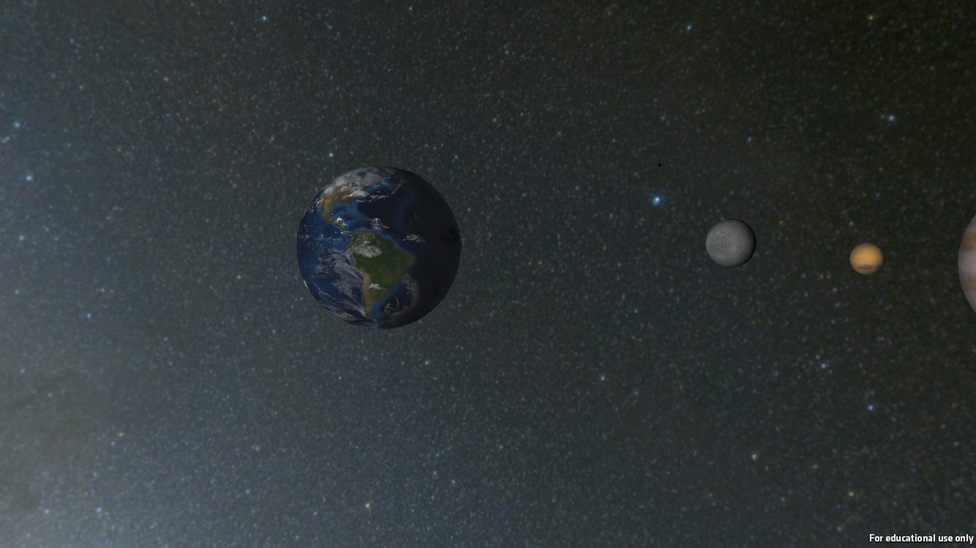

How closely do you think this represents the Earth-Moon system?

1. Sizes are wrong and the distance is wrong
2. **Sizes are right, but the distance is wrong**
3. Sizes are wrong, but the distance is right
4. Sizes are right and the distance is right

MOST USERS WILL ASSUME THAT THIS IS THE CORRECT SIZE AND DISTANCE SCALE, THOUGH IT WILL BE USEFUL TO NOTE TO THE STUDENTS THE NOTE ABOUT SCALE EARLIER.

**AT THIS POINT, STUDENTS WILL MODEL THE EARTH-MOON SYSTEM. YOU MAY USE EITHER STICKERS OR STYROFOAM BALLS. YOU WILL NEED TO REPRESENT EARTH BY A 2.5-CM (1 INCH) OBJECT AND THE MOON BY A 0.6 CM (1/4 INCH) OBJECT.**

Your instructor has given your group a couple of objects representing Earth and the Moon. In your group, agree on how far apart these need to be to best represent the proper distance scale of the Earth-Moon system.

AS IT TURNS OUT, THE MOON IS 30 EARTH DIAMETERS AWAY FROM EARTH. ON THIS SCALE IT WOULD BE 30 INCHES OR 75 CM AWAY FROM THE OBJECT REPRESENTING EARTH, WHICH APPEARS RIDICULOUSLY FAR AWAY TO MOST PEOPLE. THE INSTRUCTOR COULD HAVE A SMALL PRIZE FOR THE GROUP THAT GETS CLOSEST TO THE CORRECT SCALE MODEL.

DO NOT ALLOW STUDENTS TO DO ANY COMPUTATIONS. IT IS VERY VALUABLE FOR THEM TO SEE THAT THEIR INSTINCTS ARE WRONG.

***To find out more about the distance scales of solar system objects, do the Pocket Solar System activity. (see separate ACTIVITY)***

**PART II:**

If you are in the “SOLAR SYSTEM” part of the app, and you click on “Earth,” you might notice the following as you look around:

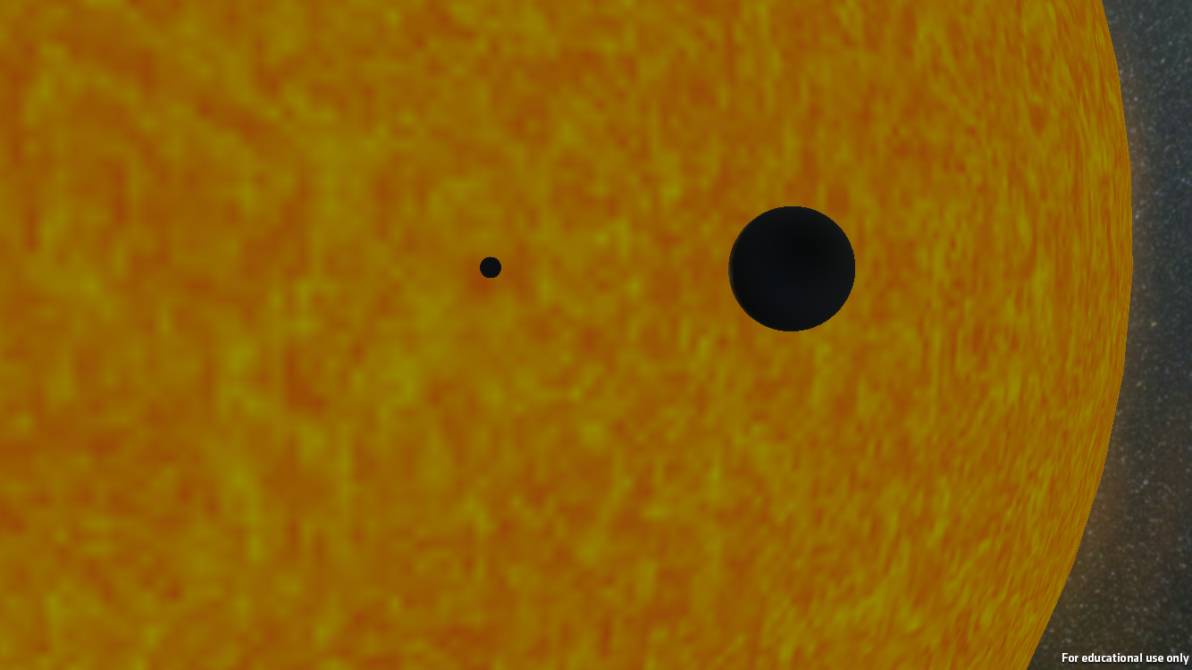

1. What do you think the two black dots are?
2. Why?

The following are ACTUAL images of the Sun as things pass in front of it.

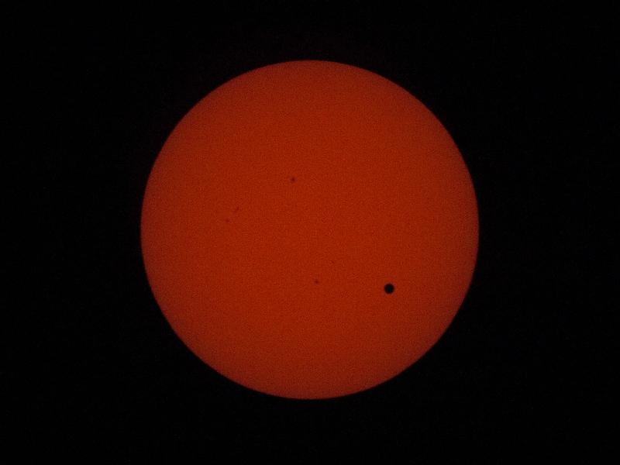 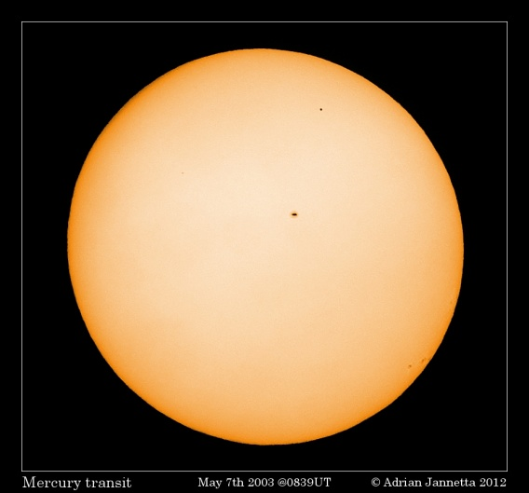 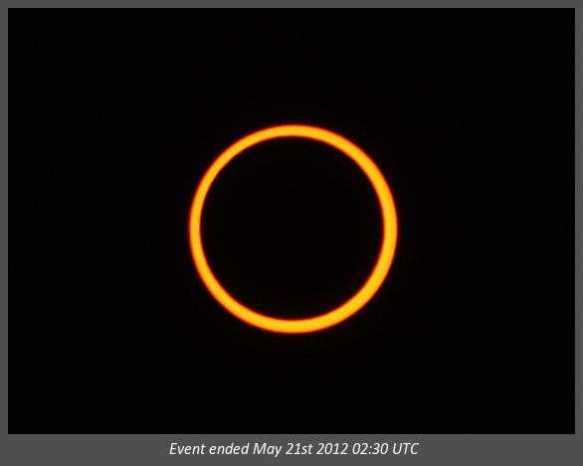

B

C

A

As objects move around in our solar system, every once in a while an object will pass directly between us and the Sun, partially blocking our view of it. In each of these three images, another object has passed in between the Sun and Earth.

1. In each case, what object do you believe has passed in front of the Sun?

A:

B:

C:

After you have completed question #3, your instructor will tell you the three objects in random order.

1. Given that the three objects, match each object with the correct picture.

A:

B:

C:

ANSWERS: IMAGE A IS VENUS; B IS MERCURY, AND C IS THE MOON. INCIDENTALLY, THE LARGER DOT IN FIGURE B IS A SUNSPOT.

1. Explain your reasoning for your answers in question 4, including why the various objects appear different sizes relative to the Sun?

THE MOON APPEARS LARGEST BECAUSE IT IS THE NEAREST OF THESE 3 OBJECTS TO US. VENUS IS A LARGER PLANET THAN MERCURY, AND IT IS ALSO CLOSER, GIVING IT A MUCH LARGER DISK WHEN IT PASSES IN FRONT OF THE SUN. MERCURY IS BOTH SMALL AND DISTANT, GIVING IT THE SMALLEST DISK.

In the “Pocket Solar System” activity, you discovered that the distance between Venus and the Sun is roughly 70% the distance between Earth and the Sun, or 0.7 AU.

Kepler was able to determine the RELATIVE distances between the planets, but what about the ACTUAL distances?

It turns out that we can use the transit of Venus – that time when Venus is between us and the Sun, making Venus appear to be a black dot on the Sun’s disk – to determine the distance between Earth and the Sun.

1. How do you think you could determine the distance from Earth to Venus by seeing the transit of Venus across the Sun?

DEPENDING ON THE LEVEL OF SOPHISTICATION OF YOUR STUDENTS, THEY MIGHT BE ABLE TO BRAINSTORM WAYS THAT OBSERVING THE DOT OF VENUS MOVES ACROSS THE FACT OF THE SUN COULD HELP US DETERMINE ITS DISTANCE. MOST GUESSES WILL LIKELY BE WRONG, THOUGH.

One process for determining distances is the use of “parallax”. Parallax is an apparent shift in perspective of a nearby object relative to a stationary foreground object. Given that Venus can be much closer to Earth than the Sun can, we can measure the difference in perspective from two different locations on Earth and use this to find the distance to Venus.

Have your student groups create a set-up as pictured below. Place a LARGE picture of the Sun on one side of the room and a table on the opposite side, such that the back edge of the table represents the Earth. Place a pedestal roughly 70% of the way from the Sun towards the table, and place a small ball on top to represent Venus. Place two protractors on the table, on either side of the central line between the Earth and Sun, equidistant from the center. These will represent two locations on Earth, from which Venus will be observed relative to a distance Sun. Tape a straw to each protractor such that it can freely pivot around the center of the protractor, and can be used to measure angles.

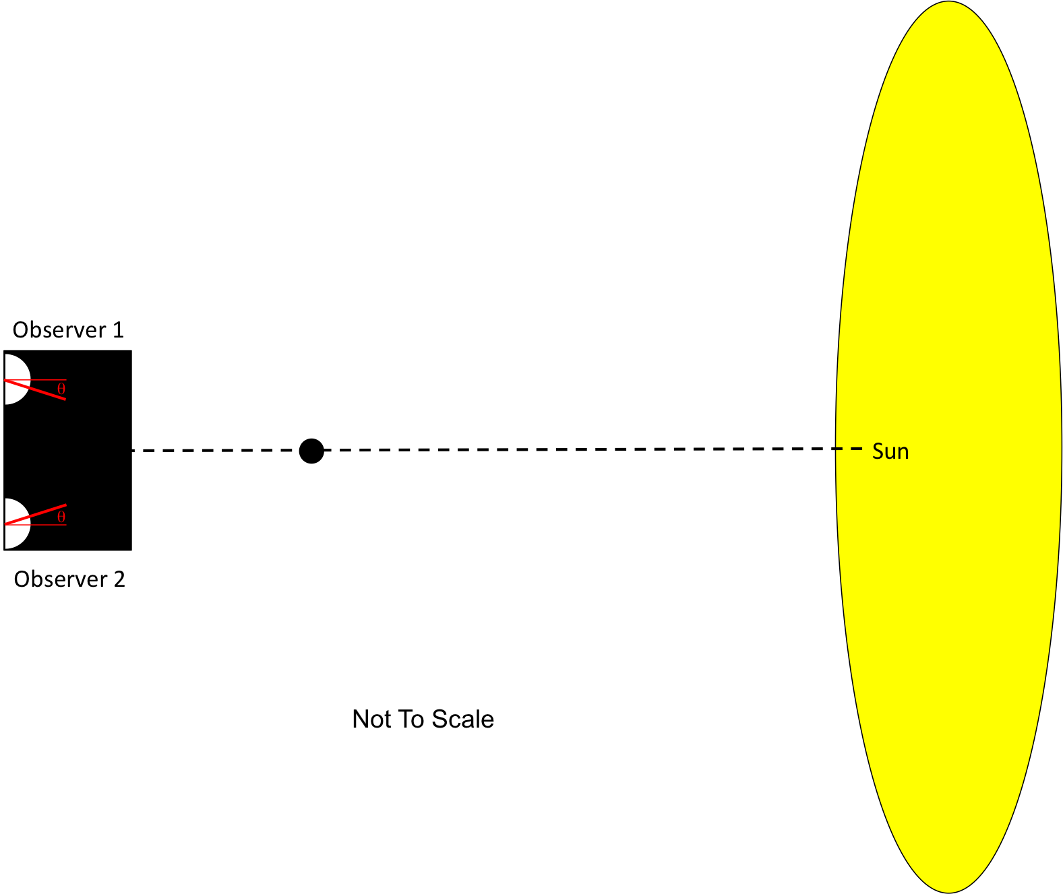

From one observation station, sight along (or through) the straw until you can see Venus. Measure the angle the straw moved relative to “straight ahead” and record this value (the angle  as shown above). Repeat from the second observation station.

1. When you moved from one observation station to the other, what was the CHANGE IN THE ANGLE of the planet’s position (in degrees)?

*(NOTE: “Straight ahead will correspond to an angle of 90 degrees on a protractor, so students will have to measure the change in angle relative to this position.)*

Reproduce your observation, but this time as you sight Venus along each straw, extend your vision beyond Venus to the Sun, and place a small sticker on the Sun to represent the portion of the Sun blocked from view by Venus, as viewed from each location on Earth. Put a 1 next to the sticker representing the obsrevation from station 1. Put a 2 next to the sticker representing the observation from station 2.

1. Compare the separation between the observation points and the separation between the dots on the Sun. Which are farther apart?

THE APPARENT POSITIONS OF VENUS (THE ‘DOTS’) ARE FARTHER APART COMPARED TO THE SEPARATION OF THE OBSERVATION STATIONS.

Now change your observation stations by moving SLIGHTLY farther away from each other by a small amount. Make sure you can still see the planet block the Sun.

1. When you increased the distance between your observation points, what happened to the distance between the apparent positions of the planet on the Sun?
   1. It decreased
   2. **It increased**
   3. It stayed the same

NOW PLACE THE PLANET AT A GREATER DISTANCE FROM THE STUDENTS TO REPRESENT THE PLANET MERCURY, WHICH IS 0.4X THE EARTH-SUN DISTANCE.

Your instructor has now changed the location of the planet between you and the Sun. USING YOUR ORIGINAL OBSERVATION STATIONS, repeat the observation above.

1. When the distance between you and the planet increased, what happened to the distance between the apparent positions of the planet on the Sun?
   1. It increased
   2. **It decreased**
   3. It stayed the same

Once you have completed the observations for the two planets from the original observation stations, draw an illustration of the two situations here. Indicate 1) the locations of the observation stations; 2) the location of the first planet; 3) the location of the second planet; 4) the lines of sight between the observation stations and the planets; 5) the angle between the lines of sight.

1. How can you use simple geometry to determine the actual distance to Venus and to the Sun? Remember that Kepler found out that the distance between the Sun and Venus was 70% the distance between the Earth and the Sun.

ANSWER: WHEN FACING THE SUN, THE OBSERVER ON THE LEFT WILL SEE VENUS TOWARDS THE RIGHT SIDE OF THE SUN AND VICE VERSA. THIS SITUATION CREATES TWO SIMILAR TRIANGLES AS ILLUSTRATED BELOW.

TRIANGLE 1 IS THE SMALLER TRIANGLE ON THE LEFT WHOSE BASE IS THE DISTANCE BETWEEN OBSERVERS AND WHOSE SIDES ARE FROM VENUS TO EACH OBSERVER.

TRIANGLE 2 IS THE LARGER TRIANGLE ON THE RIGHT.

IF WE SPLIT EACH TRIANGLE DOWN THE MIDDLE (DOTTED LINE) WE GET TWO SIMILAR RIGHT TRIANGLES. MEASURING THE ANGULAR DIFFERENCE BETWEEN THE TWO OBSERVATIONS, WE CAN USE BASIC TRIGONOMETRY TO FIND THE DISTANCE TO VENUS:

*tan  = x/d, where  = angular difference between Venus observations*

*x = distance between observers on Earth*

*d = distance from Earth to Venus*

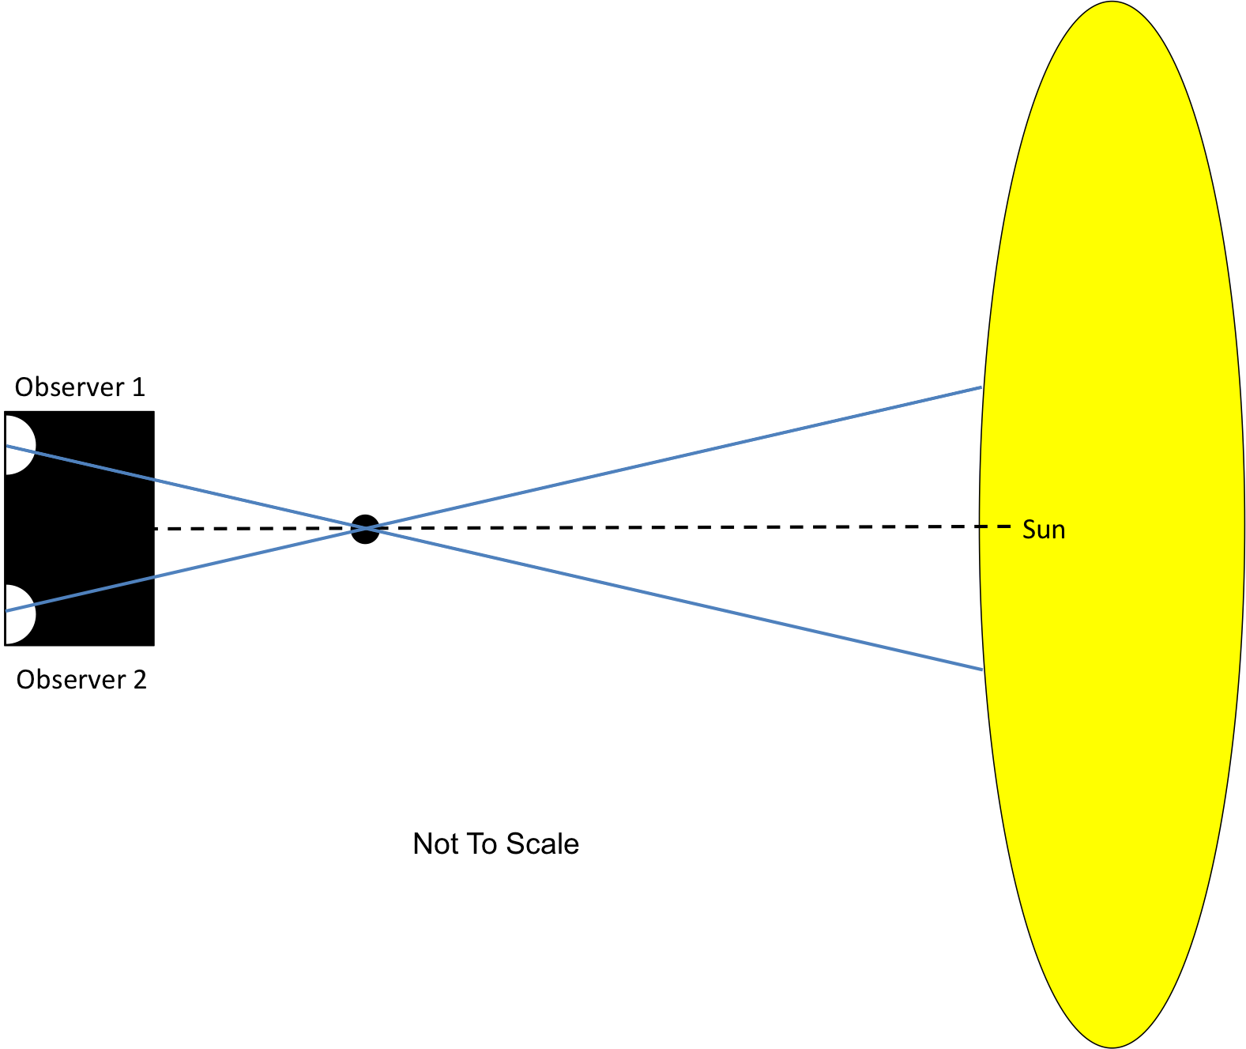

THE DISTANCE FROM VENUS TO THE SUN IS ABOUT 0.7X THE DISTANCE FROM EARTH TO THE SUN. THAT MEANS THAT THE DISTANCE FROM EARTH TO VENUS (THE SMALLER TRIANGLE ON THE LEFT) IS 0.3 TIMES THE EARTH-SUN DISTANCE. THEREFORE IF YOU KNOW THE DISTANCE FROM EARTH TO VENUS, YOU SIMPLY DIVIDE BY 0.3 TO GET THE DISTANCE FROM EARTH TO THE SUN.

**APPLYING WHAT YOU KNOW**

Astronomers have used observations taken during the transit of Venus to calculate the distance between Earth and the Sun.

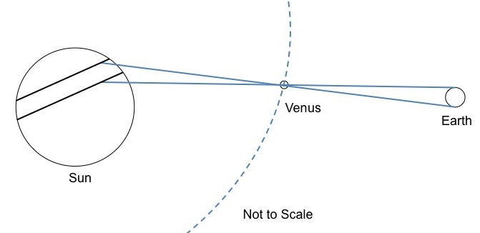

As Venus passes directly between Earth and the Sun, observers at two different locations will see Venus pass in front of the Sun along two different paths. Knowing the separation between observers, along with the angular separation between the two paths, it is possible to determine the length of the Astronomical Unit.

1. Using the method your group determined in the previous section, determine the distance from Earth to the Sun, given:

separation between observers = 9800 km

angular separation between transit paths = 45 arcseconds, or 0.012 degrees

USING THE FORMULA FROM THE PREVIOUS SECTION, YOU CAN FIND THE DISTANCE FROM EARTH TO VENUS VIA:

*tan  = x/dEV*

*dEV = x/ tan *

*dEV = 9800km/ tan(0.012)*

*dEV = 4.7 x 107 km*

IF THAT IS THE EARTH-VENUS DISTANCE, THEN THE DISTANCE FROM EARTH TO THE SUN WOULD BE:

*dES = dEV/0.3*

*dES = 4.7 x 107 km/0.3*

*dES = 1.5 x 108 km*

THE REALITY IS NOT NEARLY AS NEAT AS THIS, HOWEVER, BUT THIS EXERCISE GETS THE STUDENTS TO APPRECIATE THE DISTANCE SCALES INVOLVED IN THE SOLAR SYSTEM AND HOW ASTRONOMERS FIGURED OUT THE ACTUAL DISTANCES.