**ALL SPACED OUT: SCALE MODELS OF THE SOLAR SYSTEM**

**INTRODUCTION**: How do the objects in the solar system and the universe really compare in size? And how far away are things really? In the SCIVR “Bigger than Big” and “Solar System” apps, you get a sense of relative sizes of solar system objects and our stellar neighbors, but it’s impractical in this environment to simulate the actual sizes involved, as some objects would take over the entire field of view! Even simulating motion at light speed, it would take eight minutes to travel from the Sun to Earth. If you compress the Sun-Earth travel time to just one second, it would *still* take nearly a full day to get to the next nearest star. And there wouldn’t be much of interest to look at during those hours!

This activity picks up where SCIVR leaves off: Visualising and modeling the sizes and distances involved in the “nearby” universe: the solar system. In fact, we can use our models of the universe to learn how astronomers originally determined actual distances between solar system objects (e.g., the Earth-Sun distance).

In this activity, you will explore the relative sizes of familiar objects (Sun, Earth, and Moon), and create a scale model of the distances involved in the solar system.

**PART I:**

Take a tour through the planets in the “Solar System” part of the SCIVR app. Click on a few

planets and swing your view around so you can see the others from your vantage point.

1. Which planet is the largest planet in the solar system? Which is the smallest? How large does the largest planet appear, compared to the others?
2. If we combined the volumes of all the planets into one big volume, what fraction does the largest planet contribute to the total volume? What fraction does the smallest planet contribute to the total volume?

***To find out, complete the “Worlds in Comparison” activity***

3. The activity compared the relative sizes of the ***planets*** in our solar system, but we have ignored the Sun. Compared to the size of the Earth, how big do you think the Sun is?

That’s the relative SIZES of solar system objects. What about the SPACING?

If you are in the Solar System part of the SCIVR app, and you click on “Earth,” you might see this view of the Earth-Moon system as you look around:

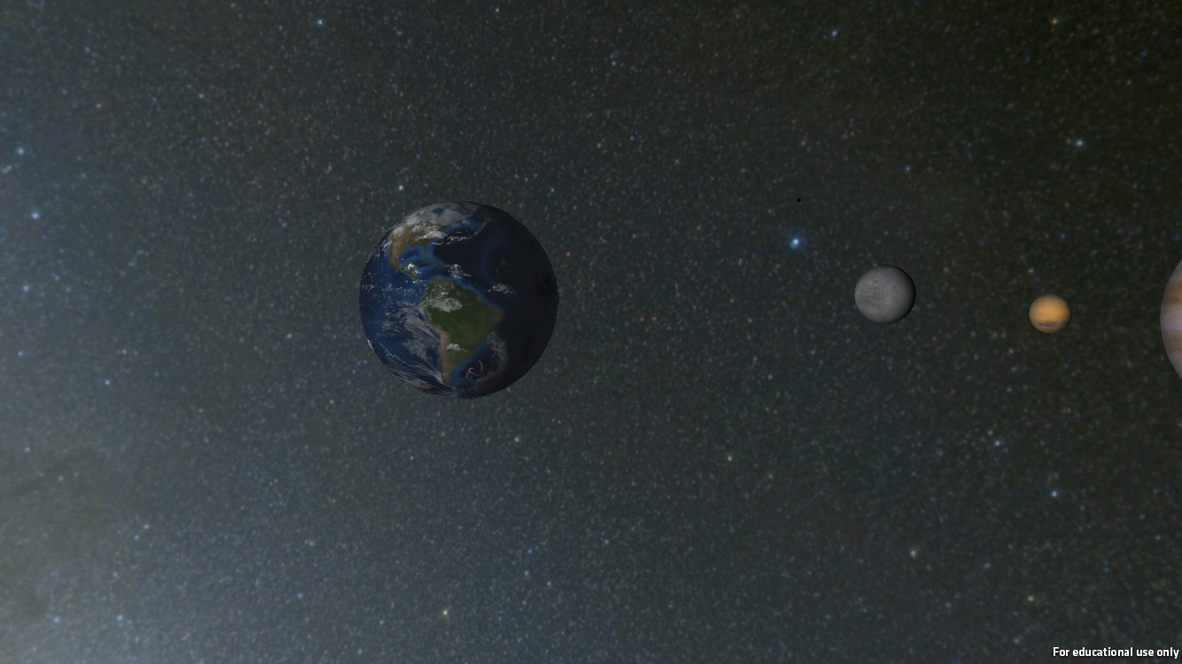

How closely do you think this represents the Earth-Moon system?

1. Sizes are wrong and the distance is wrong
2. Sizes are right, but the distance is wrong
3. Sizes are wrong, but the distance is right
4. Sizes are right and the distance is right

Your instructor has given your group a couple of objects representing Earth and the Moon. In your group, agree on how far apart these need to be to best represent the proper distance scale of the Earth-Moon system.

***To find out more about the distance scales of solar system objects, do the Pocket Solar System activity.***

**PART II:**

If you are in the “SOLAR SYSTEM” part of the app, and you click on “Earth,” you might notice the following as you look around:

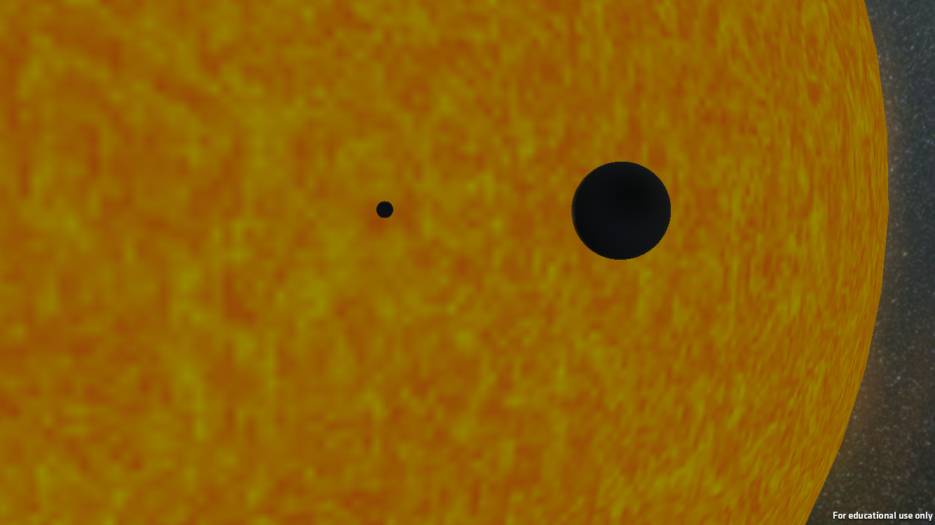

1. What do you think the two black dots are?
2. Why?

The following are ACTUAL images of the Sun as things pass in front of it.

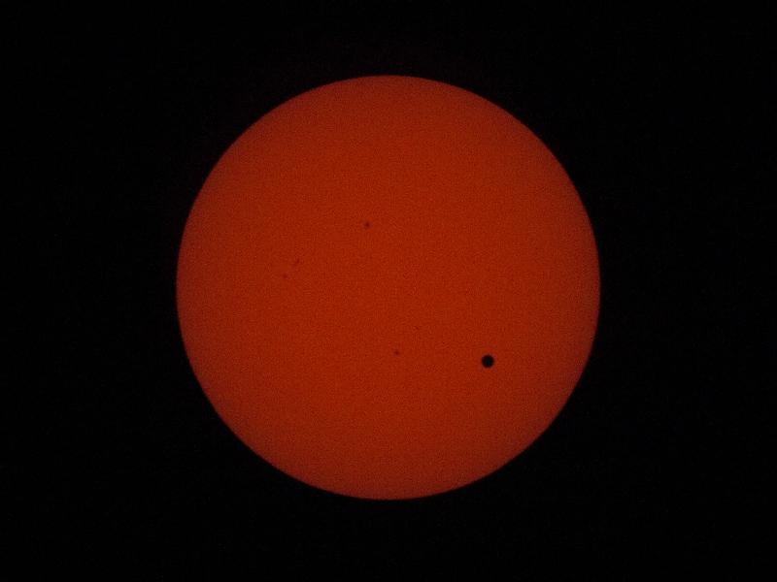 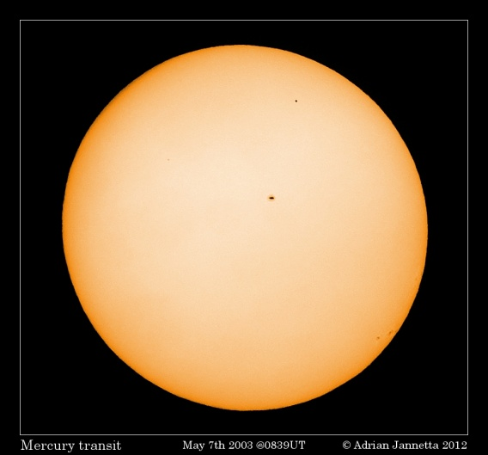 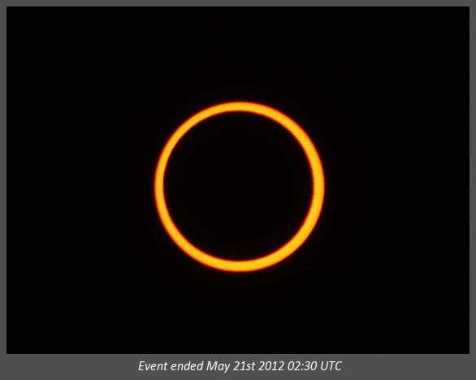

B

C

A

As objects move around in our solar system, every once in a while an object will pass directly between us and the Sun, partially blocking our view of it. In each of these three images, another object has passed in between the Sun and Earth.

1. In each case, what object do you believe has passed in front of the Sun?

A:

B:

C:

After you have completed question #3, your instructor will tell you the three objects in random order.

1. Given that the three objects, match each object with the correct picture.

A:

B:

C:

1. Explain your reasoning for your answers in question 4, including why the various objects appear different sizes relative to the Sun?

In the “Pocket Solar System” activity, you discovered that the distance between Venus and the Sun is roughly 70% the distance between Earth and the Sun, or 0.7 AU.

Kepler was able to determine the RELATIVE distances between the planets, but what about the ACTUAL distances?

It turns out that we can use the transit of Venus – that time when Venus is between us and the Sun, making Venus appear to be a black dot on the Sun’s disk – to determine the distance between Earth and the Sun.

1. How do you think you could determine the distance from Earth to Venus by seeing the transit of Venus across the Sun?

One process for determining distances is the use of “parallax”. Parallax is an apparent shift in perspective of a nearby object relative to a stationary foreground object. Given that Venus can be much closer to Earth than the Sun can, we can measure the difference in perspective from two different locations on Earth and use this to find the distance to Venus.

Your instructor will place a LARGE picture of the Sun on one side of the room and a table on the opposite side, such that the back edge of the table represents the Earth. Between you is a small ball representing a planet. There are two protractors on the table, on either side of the central line between the Earth and Sun, equidistant from the center. These represent two locations on Earth, from which the planet will be observed relative to a distance Sun. A straw taped to each protractor can be used to measure angles.

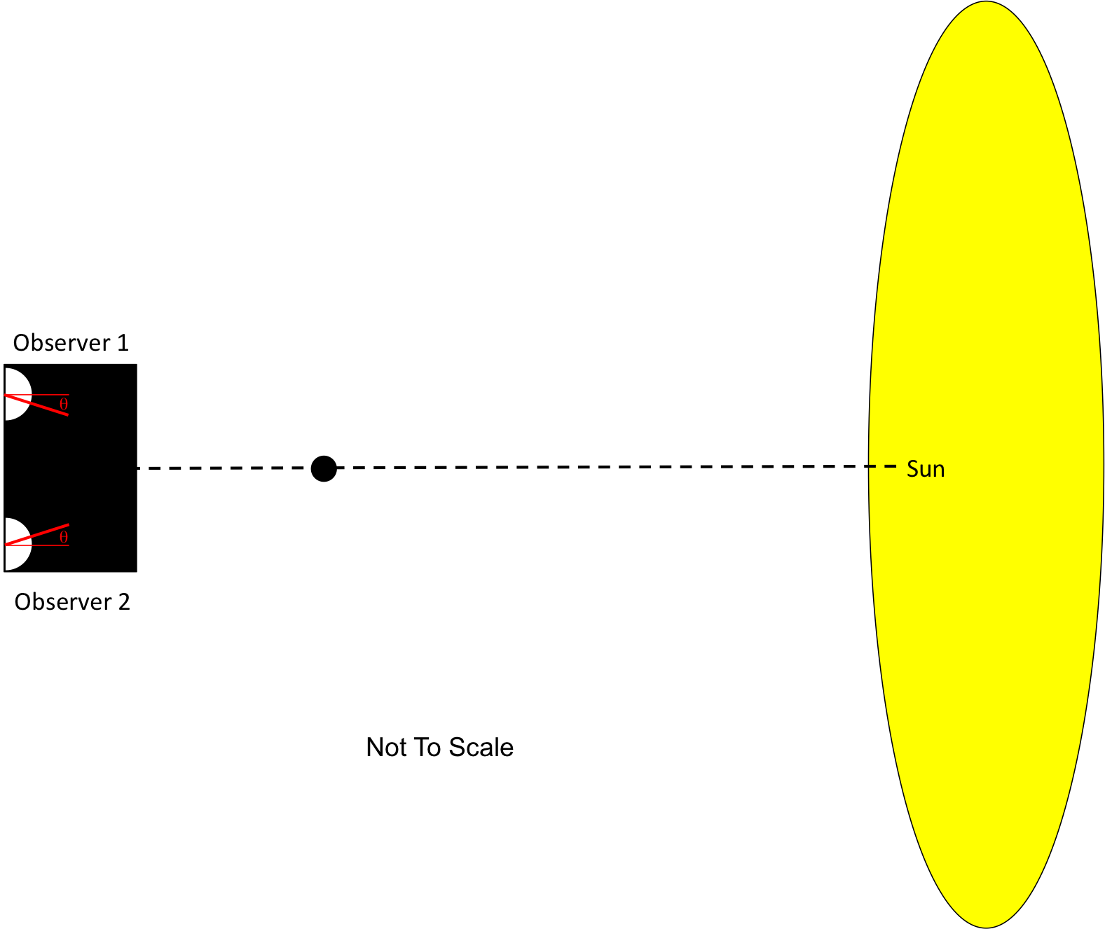

From one observation station, sight along (or through) the straw until you can see Venus. Measure the angle the straw moved relative to “straight ahead” and record this value (the angle  as shown above). Repeat from the second observation station.

1. When you moved from one observation station to the other, what was the CHANGE IN THE ANGLE of the planet’s position (in degrees)?

*(NOTE: “Straight ahead will correspond to an angle of 90 degrees on a protractor, so students will have to measure the change in angle relative to this position.)*

Reproduce your observation, but this time as you sight Venus along each straw, extend your vision beyond Venus to the Sun, and place a small sticker on the Sun to represent the portion of the Sun blocked from view by Venus, as viewed from each location on Earth. Put a 1 next to the sticker representing the obsrevation from station 1. Put a 2 next to the sticker representing the observation from station 2.

1. Compare the separation between the observation points and the separation between the dots on the Sun. Which are farther apart?

Now change your observation stations by moving SLIGHTLY farther away from each other by a small amount. Make sure you can still see the planet block the Sun.

1. When you increased the distance between your observation points, what happened to the distance between the apparent positions of the planet on the Sun?
   1. It decreased
   2. It increased
   3. It stayed the same

Your instructor has now changed the location of the planet between you and the Sun. USING YOUR ORIGINAL OBSERVATION STATIONS, repeat the observation above.

1. When the distance between you and the planet increased, what happened to the distance between the apparent positions of the planet on the Sun?
   1. It increased
   2. It decreased
   3. It stayed the same

Once you have completed the observations for the two planets from the original observation stations, draw an illustration of the two situations here. Indicate 1) the locations of the observation stations; 2) the location of the first planet; 3) the location of the second planet; 4) the lines of sight between the observation stations and the planets; 5) the angle between the lines of sight.

1. How can you use geometry to determine the actual distance to Venus and to the Sun? Remember that Kepler found out that the distance between the Sun and Venus was 70% the distance between the Earth and the Sun.

**APPLYING WHAT YOU KNOW**

Astronomers have used observations taken during the transit of Venus to calculate the distance between Earth and the Sun.

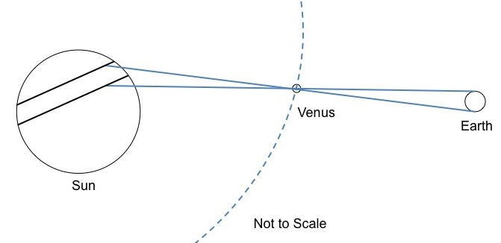

As Venus passes directly between Earth and the Sun, observers at two different locations will see Venus pass in front of the Sun along two different paths. Knowing the separation between observers, along with the angular separation between the two paths, it is possible to determine the length of the Astronomical Unit.

1. Using the method your group determined in the previous section, determine the distance from Earth to the Sun, given:

separation between observers = 9800 km

angular separation between transit paths = 45 arcseconds, or 0.012 degrees