You have just played around with the “Bigger than Big” app, and your instructor has shown you a Hubble Space Telescope photo of a patch of sky. What are FIVE things that you can tell about the photo in question JUST FROM LOOKING AT THE PHOTOGRAPH?

1.

2.

3.

4.

5.

Explore:

You will now get to experience a more familiar light source to see if you can determine anything new about the stars in the photograph. Your instructor should have set up an incandescent light bulb on a dimmer switch. You will observe the properties of the light bulb and apply what you know to the stars in the photo.

Procedure:
- Set the dimmer knob on low. Observe the COLOUR and the BRIGHTNESS of the bulb. Under the guidance of your instructor, hold your hand near the bulb and gauge the TEMPERATURE. BE CAREFUL NOT TO TOUCH THE BULB!

- Set the dimmer knob on medium. Observe the COLOUR and the BRIGHTNESS of the bulb. Under the guidance of your instructor, hold your hand near the bulb and gauge the TEMPERATURE. BE CAREFUL NOT TO TOUCH THE BULB!

- Set the dimmer knob on high. Observe the COLOUR and the BRIGHTNESS of the bulb. Under the guidance of your instructor, hold your hand near the bulb and gauge the TEMPERATURE. BE CAREFUL NOT TO TOUCH THE BULB!

- Fill in your results in the table below:

 | Colour | Temperature | Brightness
LOW
MEDIUM
HIGH

Using what you have learned from INCANDESCENT LIGHT BULBS, answer the next few questions.

Two stars are exactly the same size and distance from us. One appears orange. The other appears white. ASSUMING THAT STARS HAVE DIFFERENT COLOURS FOR THE SAME REASON THAT LIGHT BULB FILAMENTS HAVE DIFFERENT COLOURS, which one do you THINK will appear brighter?
- The orange star
- The white star
- They will both appear the same brightness
- There is not enough information to answer this question

EXPLAIN YOUR CHOICE:

Your instructor will now show you the photo again.

Do the stars in the photo behave as expected if stars have different colours for the same reason that light bulb filaments have different colours?

If not, what is different from your expectation?

Can you come up with three possible reasons for your observation?

Your instructor will now engage the class in a discussion about your observations and conclusions about light sources whose colour is related to their temperature. Make any relevant notes below.

ANOTHER LIGHT SOURCE
There is another common type of light source, though. Commonly called “discharge” tubes or “spectrum tubes,” these contain very low density gases that are energized by a high-voltage power supply.

Your instructor should have a few examples for you to observe. Once again, you should observe the colour and brightness. You should also gauge the temperature by holding your hand near the tube.

When observing the discharge tubes, do you find that there is a clear relationship between colour, temperature, and brightness? NO If so, what relationship do you note?

Look back at the image of NGC 6397. Which spectrum tube do the orange-ish stars most closely resemble?

Is there a setting for the light bulb that gives approximately the same colour? Which one?

If you had to rely only on your visual observations of these objects, could you tell whether the mechanism producing the colours in the stars was more likely the same as the light bulbs or the spectrum tubes?

Explain.

GUESS: Do you think that the colours of stars come from their temperatures (like the light bulb colour) or from their compositions (like the colours of the spectrum tubes)? DO NOT WORRY ABOUT GUESSING WRONG. You will return to this question.

Can you tell visually which mechanism is responsible for the colours of stars? _____

Your instructor will now give you a special tool for exploring the light more thoroughly. This is a diffraction grating, and it splits the different colours of light up like a prism. Observe both the light bulb and the spectrum tube through your diffraction grating.

Now do you think there might be a way to figure out which mechanism is responsible for the colours of stars? ______

There are two main reasons behind the colour of a light-emitting object: temperature (as in the case of the incandescent light) and composition (as in the case of the spectrum tubes). To figure out which is the reason behind the colours of stars, you must explore the light more thoroughly and go beyond simply the visual colour. To do this, you will need a device to split the light up.

Your instructor has provided your group with a diffraction grating or spectroscope. CDs and DVDs do the same job.

With the brightness of the lamp turned up, look towards the lamp through your diffraction grating and look for the spectrum of the lamp (you will need to look off to the side). Once you’ve found the spectrum, draw it using your coloured pencils or describe it in words.

Recall the first part of this exercise. Is the light bulb’s colour related to its temperature or its composition? _________ _____________

Your instructor will now set up a number of spectrum tubes. Note: These lamps require very high voltages, and the power supplies are very dangerous (a shock from one of these could be fatal). Please be very careful when using this equipment.

Draw the spectrum of the first lamp. Which substance is contained in the tube?
Draw the spectrum of the second lamp. Which substance is contained in the tube?
Draw the spectrum of the third lamp. Which substance is contained in the tube?

Is the colour of a spectrum tube related to its temperature or its composition?

Explain:
Your instructor will now explain a bit more about the types of spectra you have just seen, but the basic rules of objects emitting their own light are as follows:

When you see a complete rainbow, or CONTINUOUS SPECTRUM, the colour of the object is related to the TEMPERATURE.

When you see instead a series of bright lines, or EMISSION SPECTRUM, the colour of the object is related to the COMPOSITION.

There is an object in space called Eta Carinae whose spectrum looks like this:
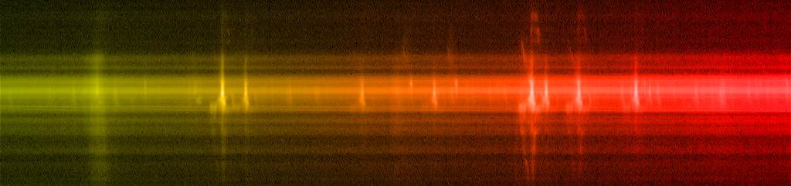
[Source - http://hubblesite.org/newscenter/archive/releases/2009/25/image/ax/format/large_web/]

Do you think the colour of this object is related to its TEMPERATURE or to its COMPOSITION?

Explain your answer.
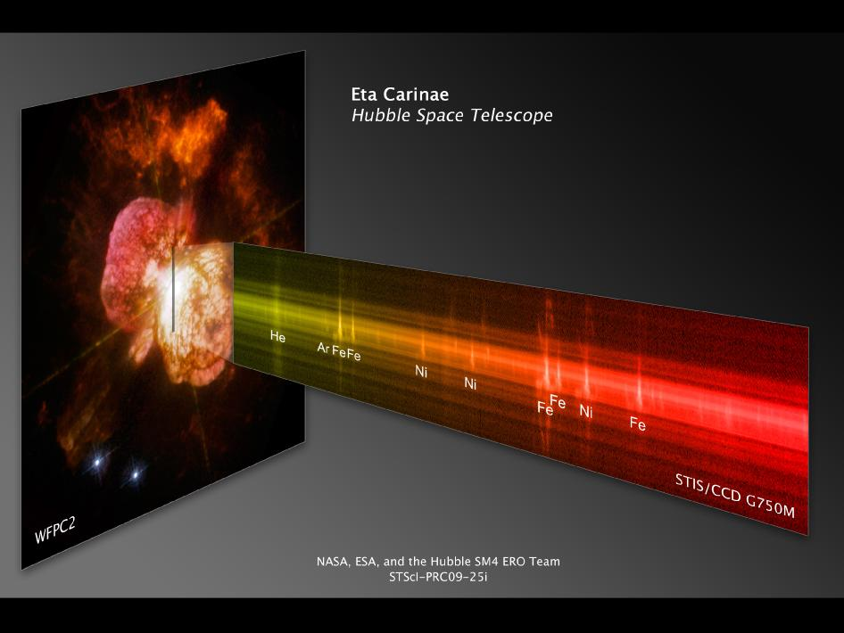

Here is another spectrum from an astronomical object:

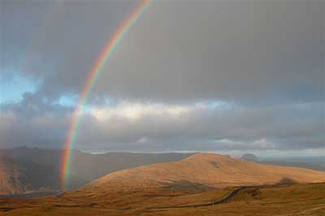
[Source - http://scijinks.jpl.nasa.gov/rainbow/]

Which astronomical object is this spectrum from?
Do you think the colour of this object is related to its TEMPERATURE or to its COMPOSITION?
Explain your answer.

Now look back at the image of NGC 6397. What type of astronomical objects are represented in the photo?

What type of spectrum do you think they have – one more like the light bulb’s, or one more like the spectrum tube’s?

Explain.

Do you think their colours are related to their composition or their temperature?

Is this the same answer you gave at the end of the previous exercise? ___________ If not, what information has changed your mind?

PERSONAL RESPONSE QUESTIONS

A light bulb's colour is a result of its...
1. composition 2. temperature
A discharge tube [or fluorescent light] (e.g. a long glass tube plugged into that big power supply) gets its colour from its...
1. composition 2. temperature

A discharge tube's spectrum looks like ________.
1. a rainbow
2. a series of different coloured lines
3. a single streak of colour
4. a light bulb’s spectrum

A light bulb's spectrum looks like _______________.
1. a rainbow
2. a series of different coloured lines
3. a single white streak
4. a discharge tube’s spectrum

A STAR'S spectrum (think of the Sun) looks like...
1. a rainbow
2. a series of different coloured lines

THEREFORE a star's colour must result from the same mechanism as a _____'s colour.
1. light bulb 2. discharge tube

AND THIS MEANS a star's colour is related to its...
1. temperature 2. composition

Now consider the image of the familiar constellation Orion.
