THE RAINBOW CONNECTION: WHY ARE STARS DIFFERENT COLORS?

INSTRUCTOR’S EDITION

INTRODUCTION: With the exception of gravitational waves, light is the only information that astronomers can use to understand objects outside the solar system. The more we understand about the interaction of light and matter, the better we can understand stars, nebulae, galaxies, and the rest of the material Universe. In fact, by splitting the light up into a spectrum and analyzing it, scientists can determine details about the object emitting the light.

In this hands-on activity, we introduce students to the fundamentals of analyzing a spectrum, or spectroscopy. To engage the student, the instructor will either use the SCIVR app and look around at various stars within the app OR show a single image from the Hubble Space Telescope that reveals that stars appear different colours.

But why? A variety of light sources – an incandescent bulb on a dimmer switch, discharge tubes, and fluorescent bulbs – hints that the colour of an object emitting its own light relates either to the temperature of the object or its composition. Students then observe the spectra of these light sources through a diffraction grating or simple spectroscope, seeing that there is a clear difference between the spectrum of an incandescent light bulb (continuous) and that of the other sources (emission). Students can then apply these simple observations to astronomical objects, such as stars and nebulae, to determine whether the stars’ colours in the original HST image are related to their temperature or composition.

**This activity was created with the support of the NASA Science Mission Directorate Education and Public Outreach for Earth and Space Science (EPOESS), which is part of the Research Opportunities in Space and Earth Sciences (ROSES), Grant Number NNX12AH11G**

MATERIALS AND HELPFUL HINTS:

THIS ACTIVITY SHOULD BE DONE IN A DARK ENVIRONMENT (room with blinds closed; windowless room; night)
STUDENTS MUST HAVE ACCESS TO A DEVICE THAT SPLITS THE LIGHT INTO A SPECTRUM
An inexpensive option: Single-axis diffraction gratings (ideally one per student, but they can share)
Another inexpensive option: Cereal box CD or DVD “spectroscope”

***Instructions for building this are found within the body of this document:
http://sac.csic.es/astrosecundaria/fr/cursos/formato/materiales/conferencias/T7_w_en.pdf

A more expensive option: Spectroscope (one per group) e.g., https://www.amazon.com/Eisco-Labs-Economy-Spectroscope-Tube/dp/B01LW986HS/ref=sr_1_3?ie=UTF8&qid=1517243493&sr=8-3&keywords=spectroscope

REQUIRED: Incandescent bulb with clear glass

PREFERRED: Dimmer (rheostat)

REQUIRED: Fluorescent light

PREFERRED: Helium discharge tube/spectrum tube

PREFERRED: At least one other discharge/spectrum tube

NOTE: IF SPECTRUM TUBES/POWER SUPPLIES ARE UNAVAILABLE, A STANDARD OR COMPACT FLUORESCENT LIGHT BULB WILL PROVIDE AN EXAMPLE OF AN EMISSION SPECTRUM.

FOR OTHER EMISSION SPECTRA, GO TO : http://chemistry.bd.psu.edu/jircitano/periodic4.html

REQUIRED: Coloured pencils

REQUIRED: Computer for instructor, projector

REQUIRED: Internet access

GOALS:
Students will be able to understand the basic concept of a spectrum.
Students will be able to identify the spectrum of light given off due to an object's
temperature.
Students will be able to identify the spectrum of light given off due to an object's
composition.
Students will be able to distinguish between an emission spectrum and a continuous
spectrum.
Students will be able to apply their findings to spectra of other objects in the Universe.

LEARNING OBJECTIVES:
Students will be able to describe the visual appearance of light sources.
Students will be able to describe the spectra of light sources.
Students will learn that the colour of an object producing a continuous spectrum is related
to its temperature.
Students will learn that the colour of an object producing an emission spectrum is related
to its composition.
Students will learn that stars (and the Sun) generally produce continuous spectra.
Students will be able to conclude that the colours of stars are related to their temperature.

EVALUATION:

Students are required to answer several questions within the activity, often justifying choices to multiple choice questions or drawing a diagram of their observations. The activity could be collected as a worksheet and these questions graded for accuracy, or the questions could be fashioned into personal response questions embedded in a guided lecture (e.g., Powerpoint presentation). Questions could also be incorporated in quizzes/exams. Instructors are encouraged to listen closely to the conversations of student groups to find out if there are any persistent misconceptions or any confusion about the activity.

BACKGROUND:

It is expected that before beginning this activity, teachers will have a firm grasp of the fundamentals of light and the electromagnetic spectrum. For a refresher, teachers may consult Chapter 5 of this free online astronomy text:
https://openstax.org/details/books/astronomy

Specifically, the following sections are relevant:
- 5.1 The Behavior of Light
- 5.2 The Electromagnetic Spectrum
- 5.3 Spectroscopy in Astronomy
*****IMPORTANT NOTE: THIS ACTIVITY FOLLOWS THE BYBEE 5E INSTRUCTIONAL MODEL: (https://www.bscs.org/sites/default/files/_legacy/BSCS_5E_Instructional_Model-Executive_Summary_0.pdf)

THUS TEACHERS SHOULD TAKE CARE NOT TO PROVIDE MUCH (if any) BACKGROUND INFORMATION TO THEIR STUDENTS. In fact, this exercise has been successfully presented with no background in outreach for primary school students, and it has served as the first day in a university-level astronomy course.

The first portion serves to ENGAGE the student – they discover that stars can appear different colors. The second portion allows the student to EXPLORE different colored light sources and the types of spectra that these sources produce. Only then will the instructor help EXPLAIN what is going on and help the student logically progress through a series of personal response questions. EVALUATION takes place along the way through question prompts. Students can ELABORATE on what they have learned by applying it to novel situations (e.g., the spectrum of Eta Carinae or determining which star in Orion is the coolest).

By the end of the activity that uses common light sources, students will be able to understand simple properties of stars and nebulae by simply applying their own observations and reasoning skills.

There are two “versions” of the activity: The student’s edition and the teacher’s edition. The student’s edition does not contain notes or answers, but in the body of the teacher’s edition of the activity are ANSWERS and several notes IN ALL CAPS that have been compiled from over a decade of using and tweaking the activity with secondary school and university students. Common pitfalls and alternative conceptions are described.

Through exploring various light sources, both simply with their eyes and then with the help of a diffraction grating or spectroscope, students have learned that the colours of light sources can be related to temperature or composition. More specifically, if the object displays a continuous spectrum, its colour is related to its temperature. If it displays an emission spectrum, its colour is related to its composition. They also see that in some cases, the picture is more complicated, but at the very least they have linked their own observations to those of objects far out of our reach, giving them a hint as to how astronomers can say with any certainty what the properties are of objects trillions of kilometers away.

WHILE EXPLORING THE SCIVR “BIGGER THAN BIG” APP, STUDENTS CAN DETERMINE THAT STARS COME IN DIFFERENT SIZES AND COLOURS. IN ADDITION, IN THE ALL SKY VIEW APP, COLOURS OF VARIOUS OBJECTS ARE SEEN IN THE VISIBLE LIGHT IMAGE OF THE MILKY WAY. THIS ACTIVITY FOCUSES ON THE COLOURS OF THE STARS AND NEBULAE SEEN IN THOSE APPS.

ONCE STUDENTS HAVE SEEN SOME OF THE DIFFERENT COLOURS OF OBJECTS IN THE UNIVERSE, THE INSTRUCTOR WILL SHOW STUDENTS A HUBBLE SPACE TELESCOPE PHOTO OF NGC 6397 (OR SIMILAR STAR CLUSTER) AND ASK WHAT THEY CAN TELL ABOUT IT JUST FROM THE PHOTO.

PHOTO OF NGC 6397 CAN BE FOUND HERE: http://hubblesite.org/newscenter/archive/releases/star%20cluster/2003/21/image/a/format/web_print/

OTHER GLOBULAR CLUSTERS CAN BE FOUND ON THE HUBBLE SPACE TELESCOPE WEBSITE: http://hubblesite.org/gallery/album/query/globular%20cluster/

IT IS IMPORTANT THAT THE CLUSTER SHOWN HAS STARS OF DISTINCTLY DIFFERENT COLOURS. OMEGA CENTAURI IS ANOTHER GOOD ONE – IT HAS BLUE, WHITE, ORANGE, REDDISH STARS.

Your instructor has shown you a Hubble Space Telescope photo of a patch of sky. What are FIVE things that you can tell about the photo in question JUST FROM LOOKING AT THE PHOTOGRAPH?

1.

2.

3.

4.

5.

THE STUDENTS WILL MOST LIKELY NOTE THAT THE STARS IN THE PHOTO ARE DIFFERENT COLOURS, APPEAR DIFFERENT BRIGHTNESSES, SEEM TO CLUSTER NEAR THE MIDDLE, AND THAT THE ORANGE-ISH STARS SEEM MORE EVENLY SPACED OUT THAN THE WHITE-ISH ONES. THEY WILL NOTE – PROBABLY IN JEST – THAT THERE IS DARKNESS IN BETWEEN THE STARS (THIS IS ACTUALLY AN INCREDIBLY PROFOUND OBSERVATION, ONE THAT GETS TO THE HEART OF COSMOLOGY AND THE BEHAVIOR OF THE OBSERVABLE UNIVERSE). THEY WILL LIKELY SUGGEST THAT THE ORANGE-ISH ONES ARE CLOSER, ALTHOUGH THEY HAVE NO EVIDENCE OTHER THAN THE FACT THAT THEY APPEAR BRIGHTER. HOWEVER, THEIR EXPERIENCE WITH THE WORLD HAS SHOWN THEM THAT ‘BIGGER/BRIGHTER = CLOSER,’ SO THIS IS A GREAT PLACE TO ASK WHAT EVIDENCE THEY HAVE TO SUPPORT THEIR “OBSERVATION” THAT THE ORANGE ONES ARE CLOSER.

SIMILARLY, THEY WILL OFTEN SAY THE ORANGE ONES ARE BIGGER BECAUSE THEY APPEAR BRIGHTER, AND BECAUSE THE IMAGES ACTUALLY SEEM LARGER. THIS IS A GOOD PLACE TO EXPLAIN THAT WITH VERY FEW EXCEPTIONS, STARS – EVEN WHEN VIEWED THROUGH LARGE TELESCOPES – LOOK LIKE PINPOINTS. FOR HUBBLE TO BE ABLE TO CAPTURE THE FAINTEST STARS IN THIS IMAGE, THE BRIGHTER ONES ESSENTIALLY BECAME OVEREXPOSED AND BLED INTO SURROUNDING PIXELS.

Explore:
AT THIS POINT, THE INSTRUCTOR WILL EXPLAIN THAT SOMETIMES OUR EXPERIENCE LEADS TO THE CORRECT ANSWER (STARS APPEAR DIFFERENT COLOURS) AND SOMETIMES IT MAKES US LEAP PREMATURELY TO A CONCLUSION THAT MIGHT NOT BE VALID (THE ORANGE STARS ARE CLOSER. WHILE THEY MIGHT BE, THE PHOTO ITSELF DOESN’T TELL US THAT).

You will now get to experience a more familiar light source to see if you can determine anything new about the stars in the photograph. Your instructor should have set up an incandescent light bulb on a dimmer switch. You will observe the properties of the light bulb and apply what you know to the stars in the photo.

Procedure:
- Set the dimmer knob on low. Observe the COLOUR and the BRIGHTNESS of the bulb. Under the guidance of your instructor, hold your hand near the bulb and gauge the TEMPERATURE. BE CAREFUL NOT TO TOUCH THE BULB!

- Set the dimmer knob on medium. Observe the COLOUR and the BRIGHTNESS of the bulb. Under the guidance of your instructor, hold your hand near the bulb and gauge the TEMPERATURE. BE CAREFUL NOT TO TOUCH THE BULB!

- Set the dimmer knob on high. Observe the COLOUR and the BRIGHTNESS of the bulb. Under the guidance of your instructor, hold your hand near the bulb and gauge the TEMPERATURE. BE CAREFUL NOT TO TOUCH THE BULB!

- Fill in your results in the table below:

 | Colour | Temperature | Brightness
LOW | ORANGISH | COOL/WARM | DIM
MEDIUM | YELLOW-ISH (BEIGE/PALE COPPER) | MEDIUM/WARMER | BRIGHTER
HIGH | WHITE | HOT! | BRIGHT!

Using what you have learned from INCANDESCENT LIGHT BULBS, answer the next few questions.

Two stars are exactly the same size and distance from us. One appears orange. The other appears white. ASSUMING THAT STARS HAVE DIFFERENT COLOURS FOR THE SAME REASON THAT LIGHT BULB FILAMENTS HAVE DIFFERENT COLOURS, which one do you THINK will appear brighter?
- The orange star
- The white star
- They will both appear the same brightness
- There is not enough information to answer this question

EXPLAIN YOUR CHOICE: WITH THE LIGHT BULB EXAMPLE, THE WHITE BULB = HOTTEST = BRIGHTEST. IF ALL OTHER FACTORS ARE THE SAME (DISTANCE, SIZE), ONE EXPECTS WHITE TO BE BRIGHTER.
Your instructor will now show you the photo again.

Do the stars in the photo behave as expected if stars have different colours for the same reason that light bulb filaments have different colours? NO

If not, what is different from your expectation?
IN THE PHOTO, THE ORANGE-ISH STARS ARE ACTUALLY THE ONES THAT STAND OUT THE MOST.

Can you come up with three possible reasons for your observation?

Your instructor will now engage the class in a discussion about your observations and conclusions about light sources whose colour is related to their temperature. Make any relevant notes below.

YOU SHOULD NOW ENGAGE THE CLASS IN A DISCUSSION OF HOW THE BRIGHTER STARS COULD BE THE ORANGE ONES. THE MOST REASONABLE POSSIBILITIES ARE…
- THE ORANGE STARS STAND OUT BECAUSE THEY’RE CLOSER
- THE ORANGE STARS STAND OUT BECAUSE THEY’RE BIGGER
- THE COLOUR OF THE STARS IS NOT REPRESENTATIVE OF THEIR TEMPERATURES, LIKE THE LIGHT BULB’S COLOUR. PERHAPS AN ENTIRELY DIFFERENT MECHANISM GIVES THEM THEIR COLOUR/BRIGHTNESS.
OCCASIONALLY A STUDENT WILL HAVE AN INTRIGUING IDEA THAT DESERVES DISCUSSION, E.G. “MAYBE THE HUBBLE CAMERA IS MORE SENSITIVE TO ORANGE.” [ASSURE THEM THAT ASTRONOMERS GO THROUGH QUITE A BIT OF WORK TO MAKE SURE THE IMAGES ARE AS ACCURATE AS POSSIBLE]

ANOTHER LIGHT SOURCE
There is another common type of light source, though. Commonly called “discharge” tubes or “spectrum tubes,” these contain very low density gases that are energized by a high-voltage power supply.

Your instructor should have a few examples for you to observe. Once again, you should observe the colour and brightness. You should also gauge the temperature by holding your hand near the tube.

When observing the discharge tubes, do you find that there is a clear relationship between colour, temperature, and brightness? NO If so, what relationship do you note? THERE SHOULD BE NONE. IF PLUGGED IN THE SAME AMOUNT OF TIME, THEY DON’T FEEL ANY DIFFERENT FROM EACH OTHER. ALSO THE BRIGHTNESS/COLOUR AREN’T RELATED LIKE THEY ARE WITH THE REGULAR INCANDESCENT LIGHT BULB.

PLEASE NOTE THAT THE SPECTRUM TUBES CAN GET EXTREMELY HOT. EITHER TURN THEM ON FOR A BRIEF TIME OR ALLOW SUFFICIENT COOL-DOWN TIME BEFORE CHANGING THEM.

Look back at the image of NGC 6397. Which spectrum tube do the orange-ish stars most closely resemble? HELIUM

Is there a setting for the light bulb that gives approximately the same colour? YES Which one? MEDIUM-ISH (THIS WILL DEPEND ON YOUR EXACT EQUIPMENT)

If you had to rely only on your visual observations of these objects, could you tell whether the mechanism producing the colours in the stars was more likely the same as the light bulbs or the spectrum tubes? __NO___

Explain. FOR SOME STAR COLOURS, YOU CAN MIMIC THE COLOUR WITH EITHER THE RIGHT SETTING ON THE DIMMER SWITCH FOR THE LIGHT BULB OR THE RIGHT TYPE OF SPECTRUM TUBE. JUST EYEBALLING THE COLOUR CAN’T TELL YOU WHICH IS RIGHT.

GUESS: Do you think that the colours of stars come from their temperatures (like the light bulb colour) or from their compositions (like the colours of the spectrum tubes)? DO NOT WORRY ABOUT GUESSING WRONG. You will return to this question.

THIS IS A GUESS – YOU WILL LIKELY FIND THAT OVER HALF OF YOUR CLASS WILL ATTRIBUTE A STAR’S COLOUR TO ITS COMPOSITION, BUT AT THIS POINT, THERE IS NO NEED TO CORRECT THEM. THEY WILL EXPLORE MORE ABOUT LIGHT IN THE NEXT ACTIVITY AND IDEALLY DEDUCE THAT A STAR’S COLOUR IS RELATED TO THE TEMPERATURE.

Is this the same answer you gave at the end of the previous exercise? ___________ If not, what information has changed your mind?

Can you tell visually which mechanism is responsible for the colours of stars? _____

Your instructor will now give you a special tool for exploring the light more thoroughly. This is a diffraction grating, and it splits the different colours of light up like a prism. Observe both the light bulb and the spectrum tube through your diffraction grating.

Now do you think there might be a way to figure out which mechanism is responsible for the colours of stars? ______

Explain.

Explore:

There are two main reasons behind the colour of a light-emitting object: temperature (as in the case of the incandescent light) and composition (as in the case of the spectrum tubes). To figure out which is the reason behind the colours of stars, you must explore the light more thoroughly and go beyond simply the visual colour. To do this, you will need a device to split the light up.

Your instructor has provided your group with a diffraction grating or spectroscope. CDs and DVDs do the same job.

With the brightness of the lamp turned up, look towards the lamp through your diffraction grating and look for the spectrum of the lamp (you will need to look off to the side). Once you’ve found the spectrum, draw it using your coloured pencils.
[THIS SHOULD LOOK LIKE A RAINBOW] :

Your instructor will adjust the brightness of the lamp. Describe how the spectrum of the lamp CHANGES when you view the DIMMING lamp through your diffraction grating. You might need to repeat the brightening/dimming process a few times to see the changes. Pay special attention to the intensity of the colours.

WHAT THEY SHOULD NOTE IS THAT THE PURPLES AND BLUES BECOME MUCH HARDER TO SEE. WHEN DIM, THE LIGHT BULB GIVES OFF LESS OF EVERY COLOUR, BUT THE PURPLE SEEMS TO DISAPPEAR.

Are there any colours that are present when it is bright that seem not to be present when it is dim? _______YES_________ If so, which ones? _______________PURPLE/BLUE________________________Are there any colours that are present when it is dim that don’t appear to be present when it is bright? _________________NO_____________ If so, which ones? _____________________________________________________________________________

Recall the first part of this exercise. Is the light bulb’s colour related to its temperature or its composition? __________TEMPERATURE_____________

Your instructor will now set up a number of spectrum tubes. Note: These lamps require very high voltages, and the power supplies are very dangerous (a shock from one of these could be fatal). Please be very careful when using this equipment.

Draw the spectrum of the first lamp. Which substance is contained in the tube?
Draw the spectrum of the second lamp. Which substance is contained in the tube?
Draw the spectrum of the third lamp. Which substance is contained in the tube?
[THIS WILL DEPEND ON THE LAMPS, BUT A FEW COMMON SUBSTANCES AND THEIR SPECTRA ARE GIVEN BELOW. AN INTERNET SEARCH ON “EMISSION SPECTRUM (ELEMENT NAME)” WILL YIELD PLENTY OF IMAGES:
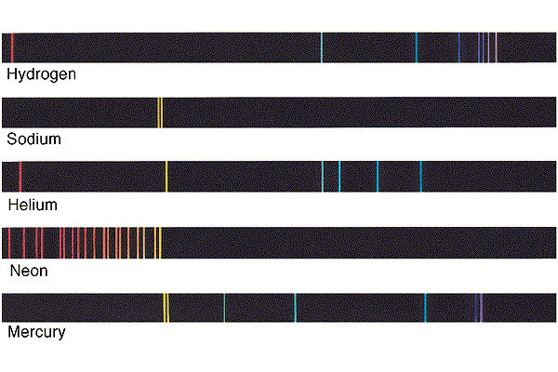
From http://wps.prenhall.com/wps/media/objects/610/625137/Chaisson/CH.00.002/HTML/CH.00.002.s5.htm

Is the colour of a spectrum tube related to its temperature or its composition? COMPOSITION

Explain:
Your instructor will now explain a bit more about the types of spectra you have just seen, but the basic rules of objects emitting their own light are as follows:

When you see a complete rainbow, or CONTINUOUS SPECTRUM, the colour of the object is related to the TEMPERATURE.

When you see instead a series of bright lines, or EMISSION SPECTRUM, the colour of the object is related to the COMPOSITION.

There is an object in space called Eta Carinae whose spectrum looks like this:
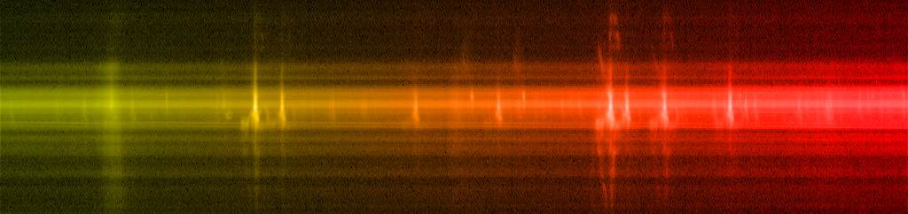
[Source - http://hubblesite.org/newscenter/archive/releases/2009/25/image/ax/format/large_web/]

Do you think the colour of this object is related to its TEMPERATURE or to its COMPOSITION? STUDENTS WILL LIKELY SAY COMPOSITION
Explain your answer. IT SHOWS THE BRIGHT EMISSION LINES.

HOWEVER, IF YOU LOOK AT IT CLOSELY, YOU SEE A VARIETY OF BEHAVIORS DEPENDING ON WHICH PART OF THE OBJECT YOU’RE LOOKING AT. CUTTING ACROSS THE MIDDLE, IT APPEARS CONTINOUS-ISH, SO FOR THAT PART OF THE OBJECT, PERHAPS IT’S DENSER. THEN YOU CAN SEE THE EMISSION LINES BEGINNING TO DOMINATE WHEN YOU GO ‘UP’ AND ‘DOWN’ FROM THE MIDDLE.

HERE IS AN IMAGE OF THE OBJECT AND ITS SPECTRUM TO ILLUSTRATE:
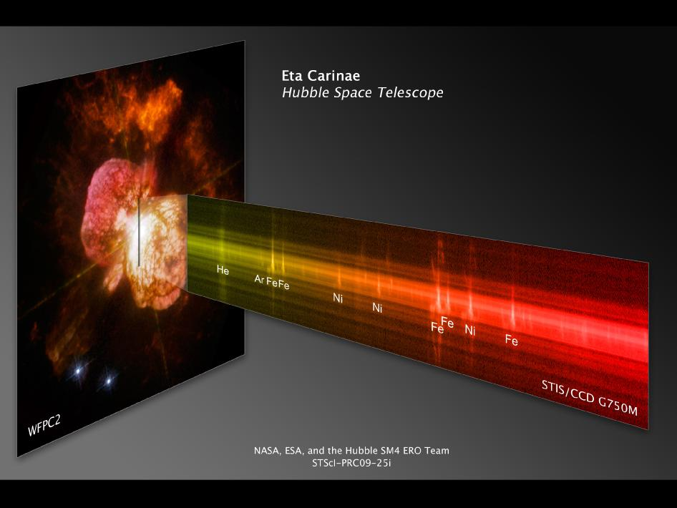

Here is another spectrum from an astronomical object:

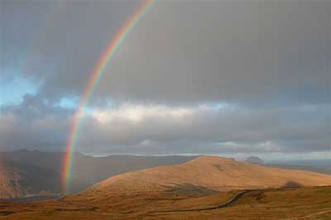
[Source - http://scijinks.jpl.nasa.gov/rainbow/]

Which astronomical object is this spectrum from? THE SUN!
Do you think the colour of this object is related to its TEMPERATURE or to its COMPOSITION? TEMPERATURE
Explain your answer. IT’S A CONTINUOUS SPECTRUM, AND WE HAVE FOUND OUT THAT OBJECTS THAT GIVE A CONTINUOUS SPECTRUM GET THEIR COLOURS FROM THEIR TEMPERATURES.

Now look back at the image of NGC 6397. What type of astronomical objects are represented in the photo?
STARS

What type of spectrum do you think they have – one more like the light bulb’s, or one more like the spectrum tube’s? MORE LIKE THE LIGHT BULB’S

Explain.
THE SUN IS A STAR, AND THE SUN GIVES A CONTINUOUS SPECTRUM (RAINBOW). SO IF THE OBJECTS IN NGC 6397 ARE ALSO STARS, THEY PROBABLY GIVE THE SAME TYPE OF SPECTRUM, WHICH IS LIKE THE LIGHT BULB’S. INTERESTINGLY, THOUGH, STUDENTS HAVE VERY LITTLE EVIDENCE AT THIS POINT THAT THE SUN IS A STAR, EXCEPT FOR THE WORD OF ALL THEIR TEACHERS.

Do you think their colours are related to their composition or their temperature?
TEMPERATURE – LIKE THE LIGHT BULB.

Is this the same answer you gave at the end of the previous exercise? ___________ If not, what information has changed your mind?
PROBABLY NOT, BUT IT MIGHT BE. THE INFORMATION THAT SHOULD HAVE CHANGED THEIR MIND IS SEEING THE SPECTRA OF OBJECTS WHOSE COLOUR COMES FROM THEIR TEMPERATURE AND THE SPECTRA OF OBJECTS WHOSE COLOUR COMES FROM THEIR COMPOSITION. INTERESTINGLY, EVEN THOUGH THEY HAVE JUST SEEN THE SUN’S SPECTRUM AND THE LIGHT BULB’S, THERE WILL STILL BE A FAIR NUMBER OF STUDENTS WHO HOLD FIRMLY TO THE ALTERNATIVE CONCEPTION THAT THE COLOUR OF THE SUN AND STARS COMES FROM THEIR TEMPERATURE. SOME ADDITIONAL PERSONAL RESPONSE QUESTIONS MIGHT HELP THEM SHAKE THIS MISCONCEPTION. FOR EXAMPLE, YOU COULD USE THE FOLLOWING SERIES OF QUESTIONS OUTLINING THE LOGICAL STEPS:

A light bulb's colour is a result of its...
1. composition 2. temperature
A discharge tube [or fluorescent light] (e.g. a long glass tube plugged into that big power supply) gets its colour from its...
1. composition 2. temperature

A discharge tube's spectrum looks like ________.
1. a rainbow
2. a series of different coloured lines
3. a single streak of colour
4. a light bulb’s spectrum

A light bulb's spectrum looks like _______________.
1. a rainbow
2. a series of different coloured lines
3. a single white streak
4. a discharge tube’s spectrum

A STAR'S spectrum (think of the Sun) looks like...
1. a rainbow
2. a series of different coloured lines

THEREFORE a star's colour must result from the same mechanism as a _____'s colour.
1. light bulb 2. discharge tube

AND THIS MEANS a star's colour is related to its...
1. temperature 2. composition

Now consider the image of the familiar constellation Orion. The coolest star is BETELGEUSE, WHICH APPEARS DISTINCTLY ORANGE-ISH IN COLOR

